**Chef Workspace and Node are Aws Instances:**

Creating ubuntu system for workstattion

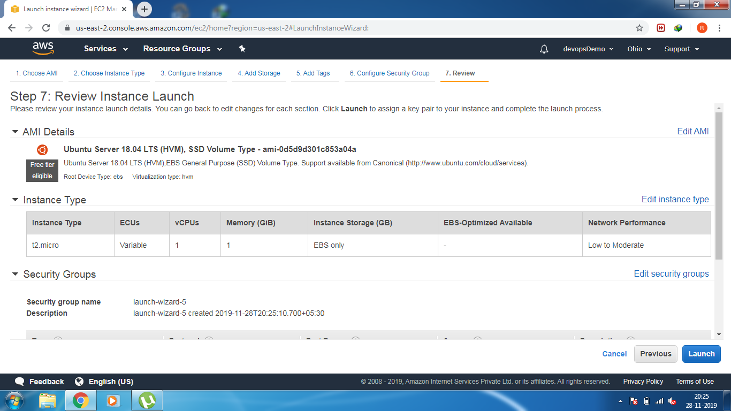

Login Ubuntu system and install chefDk

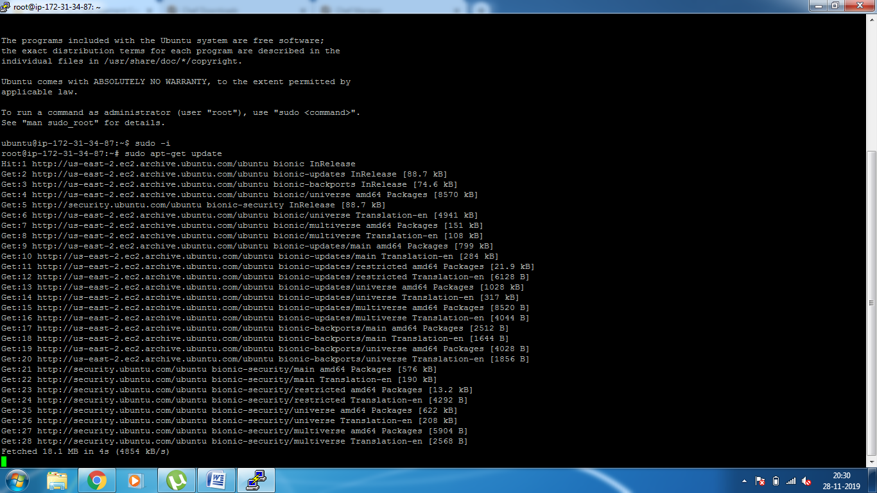

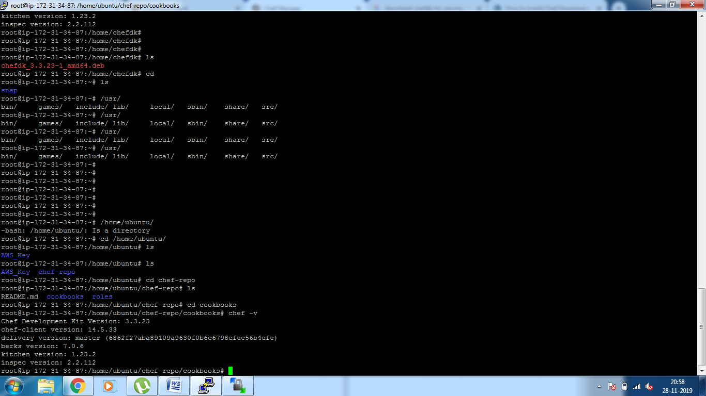

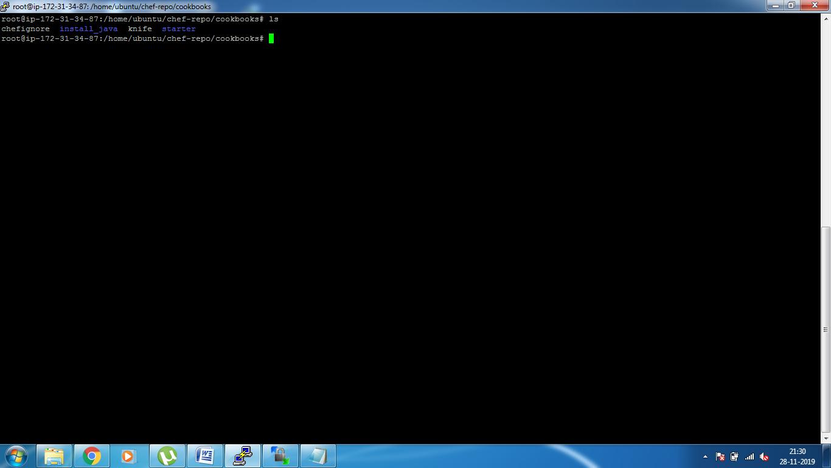

**Run knife command for bootstrap Node:**

knife bootstrap IP_address --sudo -x ubuntu -i /home/ubuntu/AWS_Key/AWS_Key_devopsDemo.pem -N "NChef" -r "recipe[install_java]"

Recipe Error

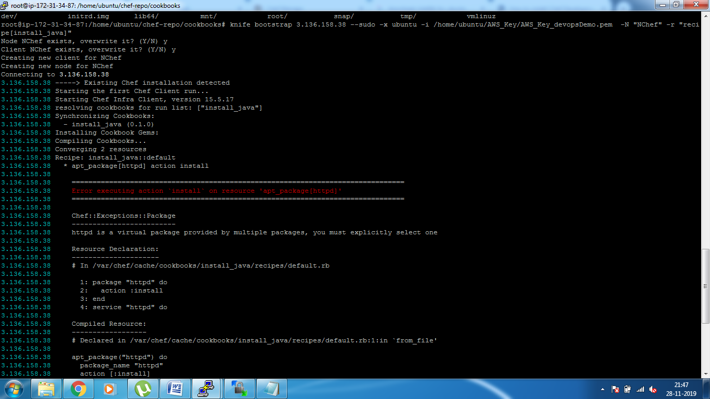

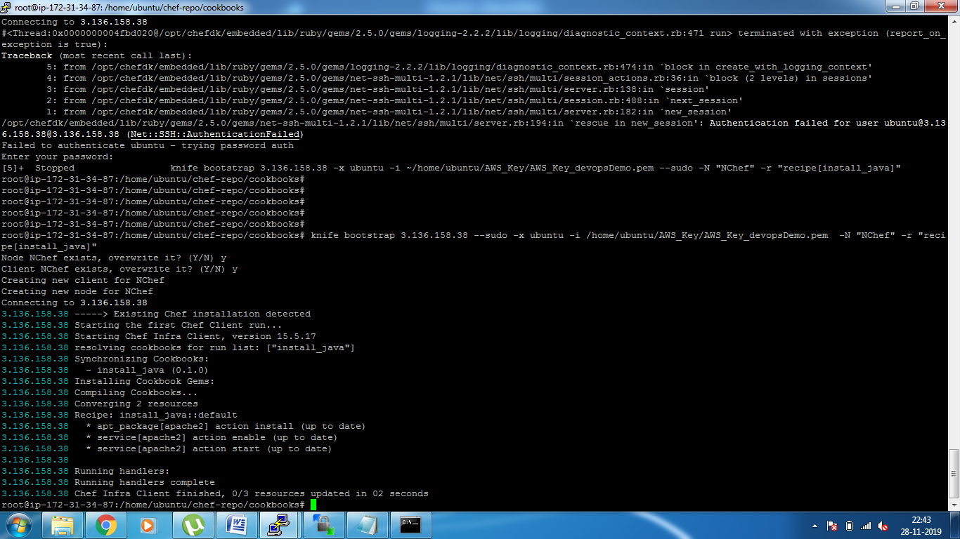

Login Ubuntu system Node:

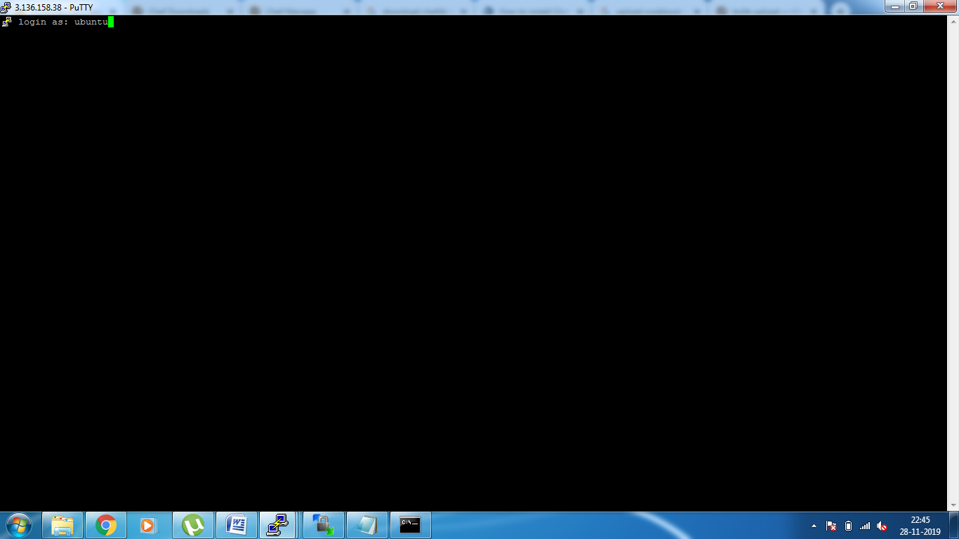

Run Chef-client for Immediate changes.